



Final Project Report

1. **Introduction**
   1. Project overviews

This project aims to analyze how various environmental factors and management factors affect growth milestone of plants. The core data provided in the dataset contains attributes like soil type, sunlight hours, humidity , temperature , water frequency and fertilizer type indicating if a plant reached a key **Growth Milestone**. The analysis will utilize **Power BI** to explore this and present actionable insights.

* 1. Objectives

To design and implement a **Power BI-based analytical solution** that visualizes environmental and management parameters and predicts plant growth stages, helping to improve crop yield and promote sustainable agricultural practices.

1. **Project Initialization and Planning Phase**
   1. Define Problem Statement

XYZ Company faces challenges in maintaining consistent plant growth due to varying environmental and management factors like soil type, sunlight, watering, fertilizer use, temperature and humidity

Currently, data from multiple greenhouses is scattered and difficult to analyse, making it hard to identify optimal growing conditions.

To overcome this, the company aims to develop a Power BI-based solution that visualizes data, identifies growth patterns, and predicts plant growth stages. This will help improve crop yield, optimize resource use, and support data-driven farming decisions.

* 1. Project Proposal (Proposed Solution)

This project focuses on leveraging Power BI to analyse environmental and management data to predict plant growth stages. By combining key factors such as soil type, sunlight hours, water frequency, fertilizer type, temperature, and humidity, the project aims to develop a data-driven decision support system for optimizing crop growth and greenhouse management.

* 1. Initial Project Planning
* Data collection
* Data Importing & cleaning.
* Data modelling
* Data Visualization
* Dashboard Insights
* Reporting & Documentation

1. **Data Collection and Preprocessing Phase**
   1. Data Collection Plan and Raw Data Sources Identified

**Source:** Single CSV file: plant_growth_data.csv

**Collection Method:** Direct upload into Power BI.

**Data Volume:** 193 records.

**Variables:** 7 variables (3 categorical, 3 continuous, 1 binary outcome).

* 1. Data Quality Report

The initial process showed **no missing values** and **consistent data types**.

The following steps outline the typical quality analysis and cleaning process performed in the **Power BI Power Query Editor**:

* + Load Data
  + Check for Missing Values (Nulls/Blanks)
  + Data Type Validation
  + Consistency Check (Categorical Data)
  + Outlier/Range Check (Numerical Data)
  1. Data Exploration and Preprocessing
  + The primary preprocessing step in Power BI will be to create a **calculated column** for user-friendly reporting.
  + **DAX Calculation:** Create a new columns and measures in the Power BI Data View.

1. **Data Visualization**
   1. Framing Business Questions
2. What is the average environmental condition across all growth observations?
3. How does water frequency impact plant growth across different soil types?
4. Which soil type contributes most to plant growth milestones?
5. How does fertilizer type affect growth performance?
6. What is the relationship between temperature range and plant growth?
7. How does humidity level affect growth milestones?
8. What is the contribution of watering frequency to total plant growth?
9. What is the overall sum of growth milestones achieved?
   1. Developing Visualizations
10. Visualization: KPI Cards (for showing average sunlight hours, average humidity, average temperature).
11. Visualization: Matrix Table (for showing water frequency according to its soil type).
12. Visualization: Decomposition Chart (for showing growth milestone count according to soil type).
13. Visualization: Donut Chart (for showing growth milestone count by fertilizer type).
14. Visualization: Column Chart (for showing average temperature by average temperature range description).
15. Visualization: Line Chart (for showing growth milestone count by humidity level description).
16. Visualization: Tree Map (for showing growth milestone percentage by water frequency).
17. Visualization: Gauge Chart (for showing total growth milestone count).
18. **Dashboard**
    1. Dashboard Design File

* First, I inserted the background image and did canvas setting from format my report page and reduced its transparency.
* Then I added the text box on top and gave the title to the dashboard.
* Started adding my visuals to the dashboard.
* Adding the visual borderline and reducing the transparency of background color of visuals.
* And finally added some colors matching the background for a dashboard to look more interactive.

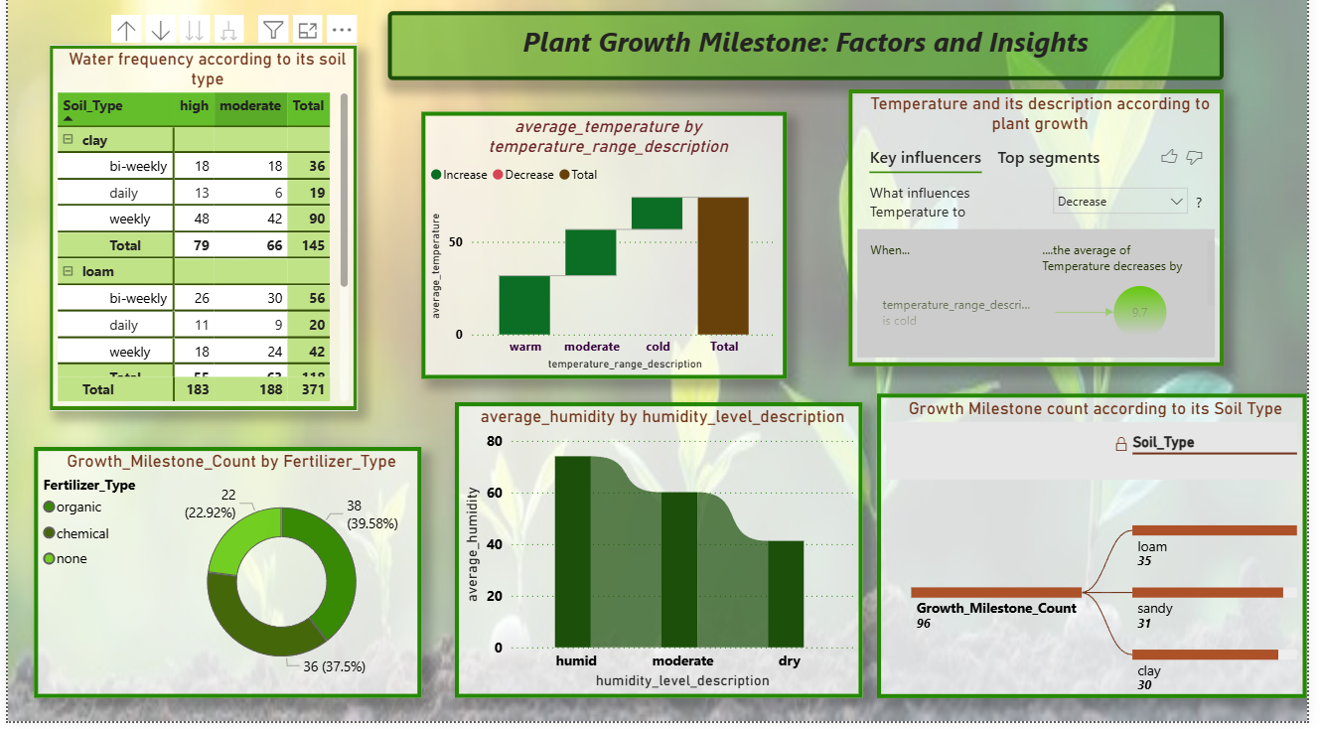

1. **Report**
   1. Story Design File

* First, I inserted the background color and image and did canvas setting from format my report page and reduced its transparency.
* Then I added the KPI card visual on top.
* Started adding my visuals to the report.
* Adding the visual borderline and reducing the transparency of background color of visuals.
* And finally added some colors matching the background for a report to look more interactive.
* And at last added some insights from the visuals of report to give an overview of data visualized.

1. **Performance Testing**
   1. Utilization of Data filters

Filters utilize a standard Power BI data model relationship (single table) and are highly efficient. Performance impact is negligible due to the small dataset size (rows).

* 1. No of Calculation Field

**Total:11**

**Calculated columns : 7 , Measures : 4**

* 1. No. of Visualization

**Total: 11**

* Water Frequency According to Its Soil Type
* Average Temperature by Temperature Range Description
* Temperature and Its Description According to Plant Growth
* Growth Milestone Count by Fertilizer Type
* Average Humidity by Humidity Level Description
* Growth Milestone Count According to Its Soil Type
* Average Sunlight Hours by Soil Type
* Growth Milestone Percentage by Water Frequency
* Growth Milestone Count by Humidity Level Description
* Growth Milestone Count
* Average Humidity, Average Temperature, Average Sunlight Hours

1. **Conclusion/Observation**

* Loam soil consistently provides the best conditions for plant growth.
* Daily watering maintains ideal soil moisture.
* Moderate temperature and humidity deliver the highest growth rates.
* Chemical fertilizers increase the short term growth , but Organic fertilizers are more sustainable.
* Environmental factors play the biggest role in achieving optimal growth milestones.

To conclude, this Power BI project demonstrates how data visualization can be used to understand and predict plant growth stages.

1. **Future Scope**

* Analyse agricultural data to identify relationships between growth conditions and plant stages.
* Develop interactive Power BI dashboards with visual insights.
* Enable decision-makers to monitor, evaluate, and optimize growth conditions in real time.

1. **Appendix**
   1. Source Code(if any)
   2. GitHub & Project Demo Link

* GitHub link: <https://github.com/689nabhika/Plant-Growth-Prediction>
* Project Demo Link: bandicam%202025-10-12%2023-27-33-888%20(1).mp4